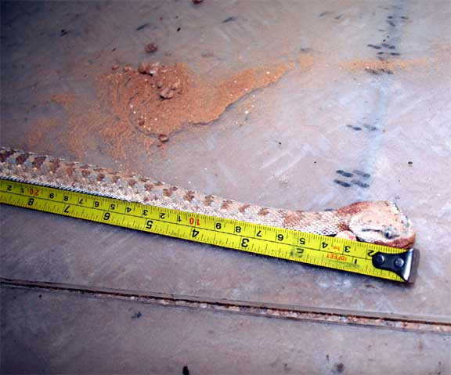
What happened?
Whilst driver was over-nighting in the desert on a rig move, he went to wash his hands at a nearby water tank and was bitten by a sand viper.
Result:

Driver was taken to local medical centre, and then passed onto Salalah Hospital for further treatment.
SAND VIPER

Learning points:

There are no infallible rules for expedient identification of poisonous snakes in the field, because the guidelines all require close observation or manipulation of the snake's body. The best strategy is to leave all snakes alone. Apply the following safety rules when traveling in areas where there are poisonous snakes:
- Walk carefully and watch where you step. Step onto logs rather than over them before looking and moving on.
- Look closely when picking fruit or moving around water.
- Do not tease, molest, or harass snakes. Snakes cannot close their eyes. Therefore, you cannot tell if they are asleep. Some snakes, such as mambas, cobras, and bushmasters, will attack aggressively when cornered or guarding a nest.
- Use sticks to turn logs and rocks.
- Wear proper footgear, particularly at night.
- Carefully check bedding, shelter, and clothing.
- Be calm when you encounter serpents. Snakes cannot hear and you can occasionally surprise them when they are sleeping or sunning. Normally, they will flee if given the opportunity.
- Use extreme care if you must kill snakes for safety. Although it is not common, warm, sleeping human bodies occasionally attract snakes.

These checks are for your safety

