NO LEAKS – “I own my barrier”
Facilitator Guide

- Preparation
- Materials
- Execution

- Preparation
About this guide
This guide is designed to help you to plan and conduct your team’s Process Safety Day event. It is divided into clear and specific sections, and contains a number of hints and tips about how to get the most out of your engagement session. It should only take about 15 minutes to read and help to planning a successful Process Safety Day.

Process Safety Day is a key engagement opportunity for the leaders with the team. These engagements should generate understanding and, more importantly, drive a long-term behavioral change that contributes to a better AI-PSM performance. It is a great way to challenge assumptions and check if everyone understands the importance and what specific role each one of us have in maintaining Asset Integrity and process safety performance.

To help you plan and design your Process Safety Day event, this guide provides ideas on how you may want to facilitate a Reflective Learning engagement with your team or site. This year, Process Safety Day will be on 15 September 2015 and the theme is “No Leaks – I own my barrier”. All guidance provided here is to support this theme.

Process Safety Day – what is it all about?
Asset Integrity and Process Safety management is crucial for our survival and future success. Good process safety management does not happen by chance and requires broad level visibility and constant active engagement with the workforce. The 2015 Process Safety Day focus is to engage with the staff and raise awareness and the profile of the Asset Integrity –Process Safety (AI-PS) program throughout the organization.
One of the primary objectives of this day is to provide a solid foundation for fostering an open dialogue between the managers and staff about process safety. This day is about engaging with staff and discussing their specific roles and how it might contribute to the AI-PS performance or risk. Any concerns raised should be noted and addressed and the team together should explore ways to improve AI-PS performance.

Introduction
Keeping our product in the pipe/facilities from the moment we start drilling until the moment we deliver the products to our customers is a must.
Discussion and reflecting on how we are managing this is therefore essential. We should know our Assets and they are safe!
Hence everybody should know their role, know their barriers, ensure they are healthy and be able to prove it. The key message to communicate is: OWN YOUR BARRIER AND TAKE CARE OF IT!
Reflective Learning
Reflective learning is a facilitated interactive group discussion. Through simple and engaging materials (video!) we make an emotional connect and let people internalize an incident. IT’S NOT ABOUT WATCHING A VIDEO. Through discussions with colleagues people learn from each other and can have an opportunity to gain new insights. At the end of the session we ask everybody to identify a personal action. WHAT ARE YOU GOING TO DO DIFFERENTLY?

Topic | Detailed Information
NUMBER OF PARTICIPANTS | 15 – 25 people – working in small teams.  (Bigger groups need more facilitators)
TIME REQUIREMENT | 60 – 75 minutes  Note: It’s a significant investment of time at operational sites, but research shows that sessions like this provide the best chance for people to reflect, really learn and change behaviours as a result.
FACILITATION | By a skilled facilitator. If you are acting as a facilitator for this session please ensure you have the right skills to facilitate an engagement to get participation and learning.  - Present with passion  - Listen and don’t talk too much yourself (the answer is in the room!)  - Be open and curious (ask open questions)  - Knowledge level of AI-PSM, Bowties, Barriers and HSE cases is crucial.
EQUIPMENT | PC/Laptop for accessing and projecting the video as appropriate.  Note: Be sure to test both video and audio equipment before the meeting.
ROOM SET UP | Chairs for all participants and a few tables. Make sure there is enough space for people to break into groups of 4 – 6 people for discussion groups.  Note: where possible do not use break out rooms, you will lose valuable time when people are moving in and out of meeting rooms.
MATERIALS | - Reflective Learning video / presentation  - Hand-out  - Action form or Bowtie poster to capture personal actions
PREPARATION | - Review the NO LEAKS I own my barrier video/presentation and these facilitator notes.  - Book a room, if possible with a table set up.  - Have the video/presentation ready installed on your PC/laptop for the session.  - Have the action sheet (Bowtie poster) printed on A2 in colour  - Agree how to capture the actions of the participants.  - Prepare the safety briefing at the start of your sessions: familiarize yourself with the alarm procedure and emergency numbers and review the evacuation floor plan for emergency exits and muster points.
TARGET AUDIENCE | - The target audience for this session is a large group of people with different backgrounds.  - When preparing it is important to know who the audience for the session is.  - You might want to bring a specialist from Process or Technical Safety to help you facilitating.
OBJECTIVES | The objectives of this session are that after participating in the engagement session we want that:  - People understand their role in managing Process Safety barriers,  - People understand that we can’t rely on just one barrier,  - Individual go out and verify that the barriers they are responsible for are in place and working.

- Materials
REFLECTIVE LEARNING VIDEO | - The video is the core tool to use during the reflective learning structure.  - The video consists of 3 parts and these will be either linked in the presentation via PDO Tube or linked to the external CD provided in the pack  - First part of the video is called “It won’t happen to me”. It makes people aware that incidents to happen and the Piper Alpha incident and memorial is used as an example  - Second part of the video is called “The Valve Story” and explains a made up incident (it did not actually happen)  - Third and final video is called “I own my barrier” and it shows how we are all connected and have a role to play in either owning a barrier, or in supporting a critical process that supports barriers.
HAND-OUT | - Use the hand-out at the start of each session  - Not all participants in the audience might be aware of the Piper Alpha incident, about the Bowtie concept or the petal model  - Allow the audience some time to read through the hand-out and explain what is coming.
CAPTURE PERSONAL ACTIONS | - After your session, make sure you get the attendees to fill out an their actions on the Bowtie Poster and upload the actions to the Process Safety Day website.  - It can be used by the teams and left hanging on a wall for future use and regular checking to see how the actions are progressing  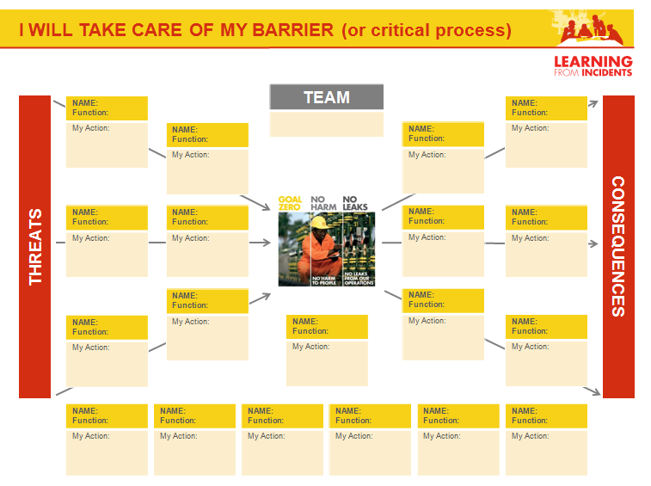

- Execution
START  5 minutes | - Welcome everyone and explain how the session is structured (open the presentation to the agenda slide)  - As the participants arrive, help to spread out the participants into groups of 4 – 6 to facilitate discussions.  - Do the safety briefing: explain alarm procedure, evacuation route and muster point(s). Check if there are colleagues present who are qualified to provide first aid.  - Explain the agenda and the hand-out. Keep the timing in mind for yourself to monitor how you are doing for time!  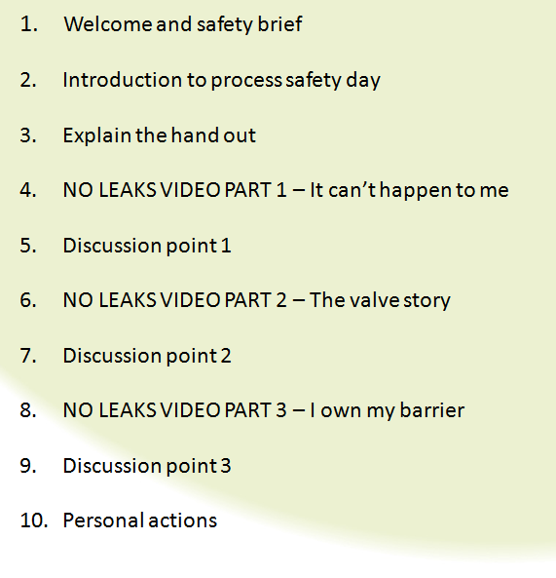  TIP: It’s important that nobody leaves the room before filling out the personal actions “Bowtie Poster” at the end of the session. By showing it at the beginning you make your expectations clear! The session will take between 60 - 75 minutes, but if the discussion is good and we want to go over that time, we can.
INTRODUCING PROCESS SAFETY  5 – 10 minutes | - The Process Safety engagement should be opened by a line manager who takes 5 – 10 minutes to explain why we focus on process safety.  - He or she could summarise how we manage process safety in PDO, what current reality in our business is and setting their expectations around barrier management.  - Using local incidents or personal experiences are advised.
EXPLAINING THE HAND-OUT  5 minutes | As explained earlier it’s important to go through the hand-out in the beginning of the session. The video contains a lot of information that not all participants might be aware of. By explaining the hand-out the audience will know what to expect.  - Explain that Piper Alpha was one of the biggest incidents in our industry where 167 people died and many more injured.  - Explain the Bowtie and point out the definition of Hardware and Human barriers and that Critical Processes supporting the barriers  - Explain the petal model and mention the different elements
VIDEO PART 1  3 minutes | Part 1: “It won’t happen to me”  - Press play via the link on the slide which will take you to PDO tube (or the video on the CD)  - The video ends with the Piper Alpha memorial. Some might know people that died in other process safety incidents.  - Give the audience a moment allowing time for personal reflection and time to think about the victims.
DISCUSSION 1  10 minutes | - When you’re ready go to the next slide to get the first questions on the screen  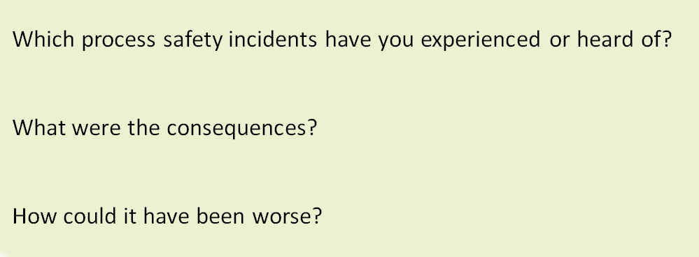  - IN this first discussion point we will NOT split up into groups, but ask for some answers plenary.  - Ask a number of people to share their personal experiences  - Once the feedback and discussion is over go to the next slide and press play for video 2
VIDEO PART 2  6 minutes | Part 2: “The Valve Story”  - When the video ends go to the next slide, the questions will appear  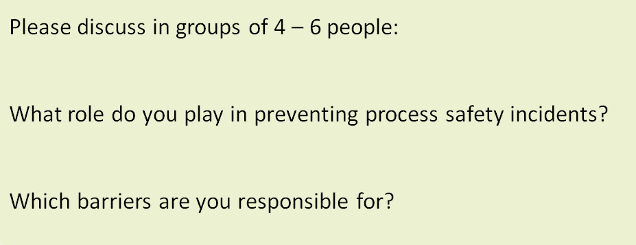
DISCUSSION 2  15 minutes | - Split up in groups of 4 – 6 people and ask people to answer the questions  - Ask 2 or 3 of the groups to give feedback to the whole group  - Once the feedback and discussion is over go to the next slide and press play for video 3
VIDEO PART 3  4 minutes | Part 3: “I own my barrier”  - When the video ends go to the next slide, the questions will appear  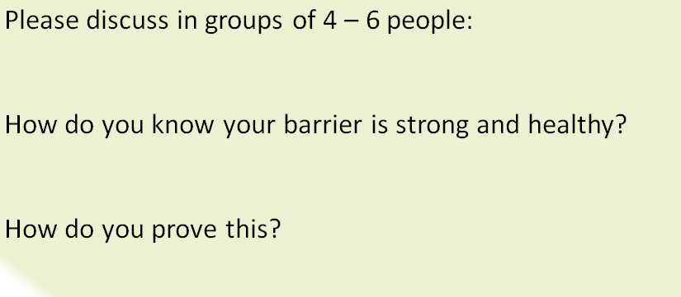
DISCUSSION 3  10 minutes | - Split up in groups of 4 – 6 people and ask people to answer the questions  - Ask 2 or 3 of the groups to give feedback to the whole group
RECAP using the hand-out  5 minutes | - Recap the discussion from the session using the hand-out  - Make notes during the session so you can give a summary to the group what you heard as key messages  - When you are ready go to the next slide. The last question will appear on the screen.  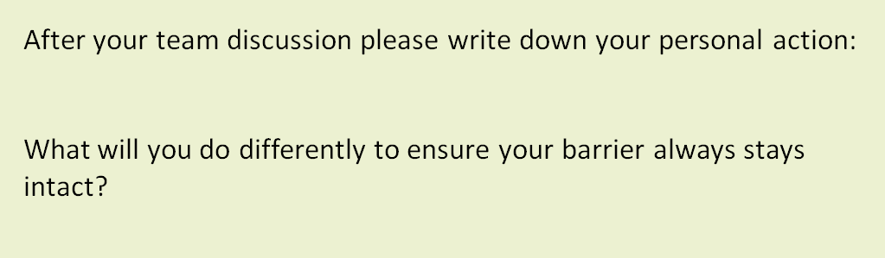
SUBMIT  Reflection and personal action  5 minutes | - Ask the participants to reflect on what they have heard and discussed in their teams, and write down a personal action on the “Bowtie Poster”

